Name:_______________________________________________Date:_______
Analyzing Plot, Character, and Setting:
“The Grinch Part II” by James Ricci.
Causes Effects
__________________________
__________________________________________________________________________________________________________________________________________________________________________________________
Setting
___________________________________________________________________________________________________________________________________________________________________________________________________________________________________________________________________________________________________________________________

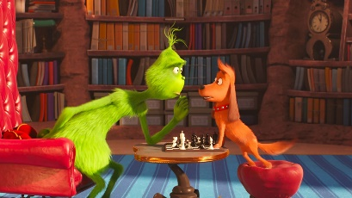

__________________________
__________________________________________________________________________________________________________________________________________________________________________________________
Character
__________________________________________________________________________________________________________________________________________________________________________________________________________________________________________________________________________________________________________________________________

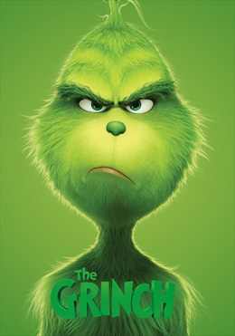
_________________________
__________________________________________________________________________________________________________________________________________________________________________________________

Plot
______________________________ ___________________________________________________________________________________________________________________________________________________________________________________________________________________________________________________________________________________________________________

