Name:______________________________________________________Date:_____________
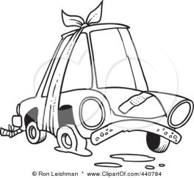
Narrative Story Elements
Reader’s Response for The Good Samaritan

Directions: Answer the following questions after reading the entire story.
Discussion Questions
What is the main idea of this story?
________________________________________________________________________________________________________________________________________________________
Who do you think the main character of the story is? Why do you think that?
________________________________________________________________________________________________________________________________________________________
What are two problems that Rey has to deal with in this story?
____________________________________________________________________________________________________________________________________________________________________________________________________________________________________
What is the setting of this story? What clues did you read to make you think that?
____________________________________________________________________________________________________________________________________________________________________________________________________________________________________
How does knowing about the setting of the story help us to understand the character Rey?
____________________________________________________________________________________________________________________________________________________________________________________________________________________________________
In what ways are you similar and/or different from the character Rey?
________________________________________________________________________________________________________________________________________________________________________________________________________________________________________________________________________________________________________________
What can we learn from Rey?
____________________________________________________________________________________________________________________________________________________________________________________________________________________________________

Extra Credit: Turn this into a theme statement that fits these 3 criteria
- Opinion statement
- Universal—applies to all people, not just to the story
- Expresses a lesson about life
____________________________________________________________________________________________________________________________________________________________________________________________________________________________________
