“This Is No Drill”: A Powerful Firsthand Account of What Really Happened at Pearl Harbor

One survivor’s unforgettable story of unfathomable courage at Pearl Harbor, told in full for the first time.
By Donald Stratton with Ken Gire from the book All the Gallant Men: An American Sailor’s Firsthand Account of Pearl Harbor
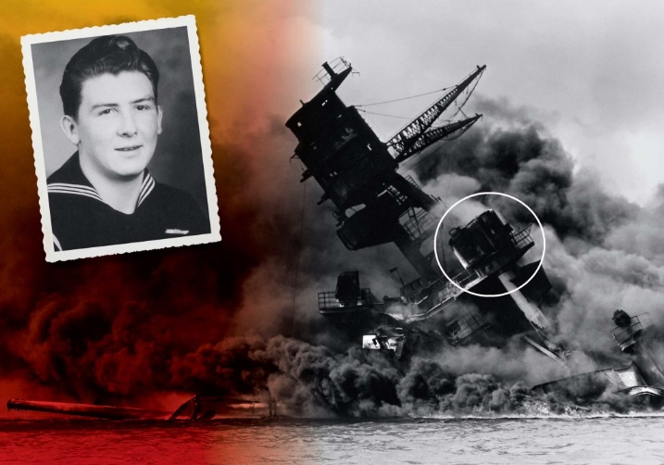Courtesy USS Arizona Memorial Photo Collection/National Park Service, Inset: Courtesy Donald Stratton
It has been said that when an old person dies, it is like a library burning down. For the past 75 years, I have tried to share what I remember of World War II, but a day will come when I can no longer speak. Then what will become of everything I experienced on December 7, 1941? That’s why I wrote this account.
A little after 5:00 a.m. The overhanging deck on board the USS Arizona
I awoke on my cot. I stowed the cot away, then went to shower. Afterward I dressed in the clothes that sailors wore on Sundays—pressed white shorts, a white T-shirt, and my sailor’s hat. At 5:30, reveille sounded over the intercom. Belowdecks, men headed to the showers.
5:50 a.m. Open waters, 230 miles north of Oahu
A Japanese armada gathered. The attack force consisted of six aircraft carriers, two battleships, two heavy cruisers, one light cruiser, nine destroyers, eight tankers, and three submarines that escorted the carriers. The ships turned east into the wind and increased their speed to 24 knots.
Between 6:15 and 6:30 a.m. Open waters, 230 miles north of Oahu
Japanese carriers launched 183 planes from their decks. The first wave of planes included 51 dive-bombers, 40 torpedo bombers, 49 horizontal bombers, and 43 fighters.
6:30 a.m. Pearl Harbor
Chow call sounded, and I ate typical Sunday fare: coffee, powdered eggs with ketchup, fried Spam, pancakes. The USS Arizona was one of 185 ships of the U.S. Pacific Fleet moored in Pearl Harbor that day. That number included eight battleships, two heavy cruisers, six light cruisers, 29 destroyers, and a number of auxiliary vessels (like tankers, repair ships, and a hospital ship). Because of poor weather, the fleet’s three aircraft carriers remained at sea.
6:45 a.m. Outside the entrance to Pearl Harbor
The USS Ward fired on an unidentified sub. It sank, and the destroyer finished her with depth charges. The Ward reported the sub’s sinking to authorities at Pearl Harbor, but the report was passed so slowly that no alert was given to other ships in the harbor.
Shortly after 7:00 a.m. Opana Point Radar Station on Oahu’s north shore
Army privates Joseph Lockard and George Elliot completed a shift, but Lockard stayed to give the more inexperienced Elliot additional training on the radar equipment while they waited for breakfast. A large blip appeared on the screen. Private Lockard concluded it was a formation of planes approaching Oahu. At the same time, Japanese carriers launched a second wave, which included 77 dive-bombers, 36 fighters, and 54 horizontal bombers.
Ten minutes later, Private Lockard notified Fort Shafter, but the operator told him that personnel had gone for breakfast. On Lockard’s radar screen, the blip was now 100 miles north of Oahu and closing. At 7:20, the operator called back, and Lockard answered. Lockard’s superior officer told him that a squadron of American planes was arriving at Pearl Harbor that morning and the blip had to be them.
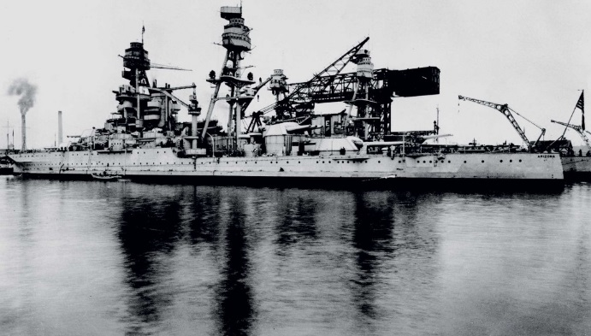Courtesy USS Arizona Memorial Photo Collection/National Park Service
7:40 a.m. Skies above Oahu
Captain Mitsuo Fuchida led the first wave of Japanese planes along the island’s north shore. Nine minutes later, his radioman signaled for the attack on Pearl Harbor to begin.
7:51 a.m. Wheeler Field
Japanese Zeros attacked aircraft, hangars, and buildings on the airstrip.

7:53 a.m. Ewa Mooring Mast Field
Enemy planes struck the airstrip as Fuchida radioed on broadband “Tora, Tora, Tora,” which meant a “lightning attack” and alerted his superiors that a surprise attack had been achieved.
7:55 a.m. Pearl Harbor
I was belowdecks while prep for morning colors sounded. At the start of each day, a signalman in the Pearl Harbor tower raised a white-and-blue “prep” flag. This signaled the color guards on the ships to raise their American flags. Seven battleships were moored on Battleship Row, along the southeast shore of Ford Island. Ford was a small island in the harbor, cut in half by a runway. The Arizona was sandwiched between the island on one side and the repair ship Vestal on its seaward side.
As I stepped into the sunshine on the forecastle deck, I heard the drone of aircraft engines and bombs exploding on Ford Island. Several of us ran to the bow to see planes on the runway bursting into flames and the water tower toppling over. The men pointed overhead. Craning my neck, I recognized the red “meatballs” on the silver wings of the planes doing the bombing: Japanese Zeros, emblazoned with the nation’s Rising Sun disk. They circled in figure eights like birds of prey. We ran to our battle stations.
I sped up steel ladders to get to my station. As I was running, I felt a wallop on the ship’s hull, followed by a muffled explosion. I raced up one ladder to the radio shack, up another ladder to the signal bridge, up a third ladder to the bridge, and finally up a fourth ladder to the sky control platform.
I looked over my shoulder at the harbor, which was in chaos. A Zero bore down, splintering our deck. It flew so low, I could see the pilot taunting me with a smirk and a wave. The air defense alarm sounded, followed by general quarters: “Attention! Attention! Attention! Man your battle stations! This is no drill! This is no drill!”
The deck was a frenzy of sailors. As Lauren Bruner raced up the ladder toward me, a Zero fixed its sights on him. One shot hit the back of his lower leg. He limped onto the platform, a trail of blood following him. The rest of our team spilled into the metal enclosure, called the director. This was our station and where we—Harold Kuhn, Russell Lott, Earl Riner, George Hollowell, Alvin Dvorak, Fred Zimmerman, Frank Lomax—directed the antiaircraft guns. I set the dials in the director that engaged the gears to set the sights of the guns. We loaded the ammo and fired at the Zeros. But they were flying so low, we risked hitting the Vestal on one side and our men on Ford Island on the other.
We turned our sights on the high-altitude bombers and fired at a 90-degree angle. We sent volley after volley of fire, but the Japanese bombers were too high and our shells couldn’t touch them. It was like boxing an opponent whose reach was twice what yours was. No matter how many times you swung or how hard, you could never hit back. All the while, you were getting pummeled.
We took so many hits, and not just our ship. From a hatch, I watched Japanese planes circling before coming straight down Battleship Row. I observed the Tennessee and the West Virginia take hits. I witnessed the Oklahoma lurch to one side, then roll over and sink. I saw a fireball in the dry dock where the Pennsylvania was.
The entire fleet was being destroyed before my eyes. Great billows of black smoke were eating up the blue sky. Torpedoes slammed against our hull, spewing geysers of water. Ships were taking on water, listing, capsizing. From those ruptured ships spilled oil that congealed when it hit the water and caught fire. It seemed the whole harbor was in flames. The hellish sight of blacks and reds and yellows, devouring everything. The sulfurous smell of burning fuel. The acrid smell of exploding gunpowder.
And the noise—it was deafening. One explosion followed another, and after each you could hear twisted metal writhing, letting out the most wretched sound, as if it were in agonizing pain. As soon as one dive-bomber dropped its torpedo, it pulled away while another plane swooped down to strafe us. Machine gun bullets ricocheted off metal. The screams of our men, their bodies engulfed in flames. And the fury of our own antiaircraft guns reverberating inside our metal cubicle so loudly, I felt my eardrums would burst.
With each bomb that hit, the ship shuddered. Another bomb whistled, and we braced for impact. But it hit the Vestal instead. The repair ship was in flames, and its crew was trying to extinguish them.
We were sitting ducks. Not just the Arizona, but every ship in the harbor. And there was nothing we could do. With few exceptions, our planes, which the Japanese hit first, never got a chance to get off the ground. We couldn’t head to open waters, because it took two and a half hours for the boilers of a battleship to fire up. So we threw our shells into the sky, hoping shrapnel might shatter a cockpit, rupture a fuel line, clip a propeller. It was all we could do. Shoot and hope. And with each burst that fell short, we lost a little more hope.
Zeros strafed the ship, their bullets ripping up the deck and shredding any sailors on it. With each pass, the Japanese pilot smiled or waved. The whole lot of them were cowards and murderers. Without a declaration of war, they waged war on us. Without warning. Without mercy. Without conscience. We took another hit, which thundered through the ship. It struck the starboard side, but it didn’t explode. At the same time, I saw two torpedo wakes heading directly toward us. I braced for the impact. Which never came. Another lucky break. Until seconds later …
8:10 a.m.
A great sucking sound, like a whoosh, rocked the ship with concussive force. A 1,760-pound armor-piercing bomb, dropped from 10,000 feet above, had penetrated four steel decks to the ammunition magazine. The blast blew a turret into the air, which then came crashing back onto the deck. Black smoke spewed out of the forward smokestack, and an expanding fireball shot 500 to 600 feet into the air, engulfing those of us in the director. The blast showered the Tennessee with tons of twisted metal and the twisted parts of our men.
As flames shot through the two openings of our enclosure, we tried to take shelter under some of the equipment. But the flames found us. On the deck, men stumbled around like human torches. Others jumped into the water, and when they did, you could hear them sizzle. James Cory, one of the Marines on board, recalled what he saw from the quarterdeck: “These people were zombies, in essence. They were burned completely white. Their skin was just as white as if you’d taken a bucket of whitewash and painted it white. Their hair was burned off; their eyebrows were burned off … Their arms were held away from their bodies, and they were stumping along the decks.”
While that horrific scene was unfolding below us, billows of black smoke pushed into where we were, stinging our eyes, filling our nostrils, our throats, our lungs. We coughed out smoke, unable to catch our breath because the fire had burned off our oxygen. The compartment we were in suddenly became claustrophobic, and two men bolted out the door. I would never see them again.
As we felt our way along the metal walls, the heat scorched our palms. The metal floor was so hot, we could feel the heat through the soles of our shoes. We hopped on one foot, then the other. Once on the outer platform, we moved toward the ladder. But flames from below leaped up the steps and barred our escape. There was no way down, and the metal platform we were standing on was growing hotter.
I looked at myself. My T-shirt had caught fire, burning my arms and back. My legs were burned from ankle to thigh. My face was seared. My hair was singed off, and part of an ear was gone. I stood in a stupor until a breeze parted the smoke, revealing a sailor on the Vestal. It was Joe George, who was following orders to cut the lines that tethered his ship to the Arizona so they could head to open waters.
We called to George, motioning for him to throw us a monkey’s fist, a lightweight heaving line knotted around a metal ball and attached to a thicker rope. If we could secure a rope between the two ships, then perhaps we could make it to the Vestal. I looked at my arms. Sheaths of skin had peeled off and were draping over each arm. I tore off one length of skin and threw it on the floor of the platform. Then the other. The remaining tissue was a webwork of pink and white and red, some black, all of it throbbing. My focus narrowed to George and the ball in his hand. He threw it, but it fell short. He gathered up the line and lobbed again. Short once more. George was perhaps the strongest man in the harbor, an All-Navy boxer. He was the only man with a prayer of getting that line to us—if he couldn’t do it, then no one could.
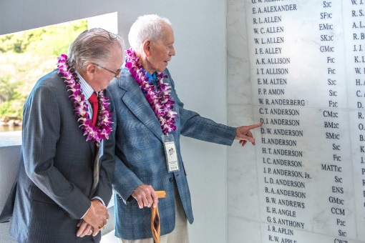Courtesy USS Arizona Memorial Photo Collection/National Park Service
George collected the rope once more. For a third time, he tossed it with all his strength. It sailed from one wounded ship to another, across flames, smoke, and carnage. I tracked it with my eyes and caught it in the air. I tied the rope to the railing, cinching it tight, and George secured his end. The rope stretched 70 feet to span the water below us, which was 45 feet down, slicked with fuel that had caught fire. Our only hope was to make it to the Vestal, hand over hand across the rope. But the flesh had been burned off all of our hands, and using those raw fingers and palms would be at best excruciating, and most likely impossible.

The first in line was Harold Kuhn. He wasn’t as badly injured as the rest of us, and so he would test the rope to see if it would hold. We looked down at the flames that swept between the two ships. Then we looked at George on the Vestal; his captain was next to him. The officer barked an order, but George stood defiant, glaring at him. The officer left. George waved Kuhn over. As Kuhn made his way across the rope, it started to sag. We recoiled at the sight. A sagging line meant the descent would be steeper, and we’d have to go uphill at the end. George called out to Kuhn, and the rest of us echoed him: “You can make it!” “Come on, now!” “Keep going!” If Kuhn couldn’t do it, how could we in our condition? But he made it. Kuhn made it!
A Japanese Zero caught sight of us on the Arizona. We ran into the director to take cover. None of the bullets hit us—this time. It was now or never.
I started hand over hand across the line, feeling a surge of adrenaline. The exposed tissue on my legs and arms felt the heat from the burning oil below me. The pain was excruciating. But somehow my hands kept going. Maybe I felt I would be letting the men down if I gave up. Or perhaps I knew that if I let go of the rope, the rest of the men might not make the attempt. George extended his hand to me as he snatched me from the flames.
One by one, each of us miraculously made it to the Vestal. We hadn’t fallen. And we hadn’t been hit by machine gun fire. We had help from the good Lord, I’m sure of that. One thing is for certain: Had Joe George not stood up for us—had he not been a rebel and refused to cut the line connecting the Vestal to the Arizona—we would have been cooked to death on that platform. If anyone deserved a Medal of Honor that day, in my opinion, it was him. And I know at least five others who would second that.
We waited on the Vestal as George and several men cut the mooring lines. But before the ship left for open waters, its men flagged down a motor launch. We Arizona escapees were helped into the launch, which brought us to shore and medical help.
As I looked back at the harbor billowing with smoke, seeing the Pacific Fleet destroyed where they were moored, staring at the remains of the Arizona engulfed in flames … the devastating sweep of it was too much.
Now I want to save from that fire something of my memories of the Arizona 75 years ago, so that my grandkids and all of the children after them can understand why it matters.

Editor’s note: After suffering burns over more than 65 percent of his body, Donald Stratton spent ten months recovering in military hospitals. He was medically discharged from the Navy in 1942, but one year later, he re-enlisted in the military and served as a gunner’s mate on the USS Stack in the Pacific. He spent most of his postwar career working for a diving company that helped build oil rigs. He lives in Colorado Springs, Colorado.

