R.A.F.T.
(role, audience, format, topic)
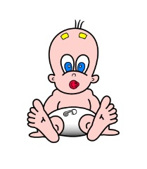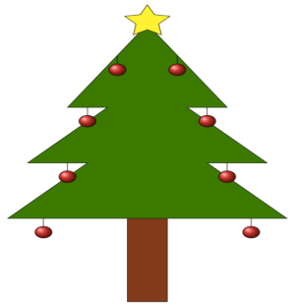
R: Role of Writer- Who are you? a principal, Beethoven, a human heart, a remote control
A: Audience: To whom is this written? a corporation, a scientist, a lawyer, a family
F: Format: What form will it take? letter, poem, journal, letter of complaint, instruction manual
T: Topic: What is the topic and intent of the writing? persuade someone to accept an invitation,
demand payment, plead for leniency, inform of terms

Write down some examples below for each part of the assignment:

Roles:

Audiences:

Formats:

Topics:

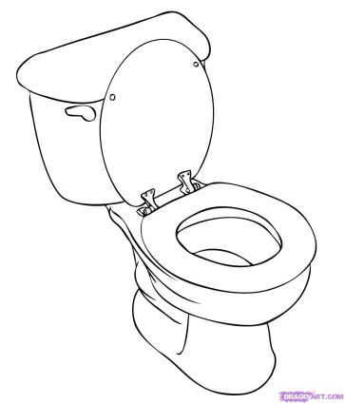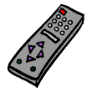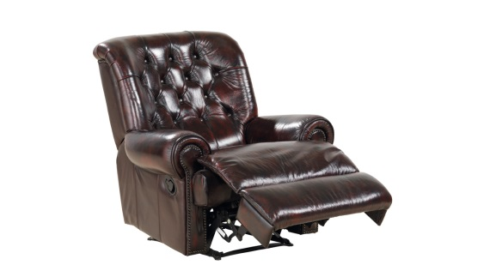

Now decide which one you will complete and write it on the other side of this page.

__________________________________________________________________________________________________
__________________________________________________________________________________________________
__________________________________________________________________________________________________
__________________________________________________________________________________________________
__________________________________________________________________________________________________
__________________________________________________________________________________________________
__________________________________________________________________________________________________
__________________________________________________________________________________________________
__________________________________________________________________________________________________
__________________________________________________________________________________________________
__________________________________________________________________________________________________
__________________________________________________________________________________________________
__________________________________________________________________________________________________
__________________________________________________________________________________________________
__________________________________________________________________________________________________
__________________________________________________________________________________________________
__________________________________________________________________________________________________
__________________________________________________________________________________________________
__________________________________________________________________________________________________
__________________________________________________________________________________________________
__________________________________________________________________________________________________
__________________________________________________________________________________________________
__________________________________________________________________________________________________
__________________________________________________________________________________________________
__________________________________________________________________________________________________
__________________________________________________________________________________________________
__________________________________________________________________________________________________
__________________________________________________________________________________________________
__________________________________________________________________________________________________

