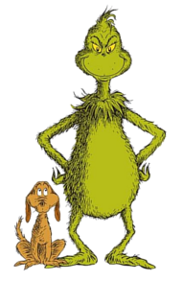
The Grinch Part II
By James Ricci

Name: _______________________________________________
The Grinch was updated in 1994. Can you spot the updates from the original? Once you’ve spotted them, can you explain their significance? List any updated details below and then use the space to explain how you knew they were updates or why the author chose to use those specific details.
Details Explanation

