FORMS OF GOVERNMENT
The chart below should help you decide on a form of government for your Utopia. You may combine characteristics of more than one government and create a new name. You MUST be able to explain the form of govermnent that will be in place in your soceity and you must have reasons supporting why you chose it.
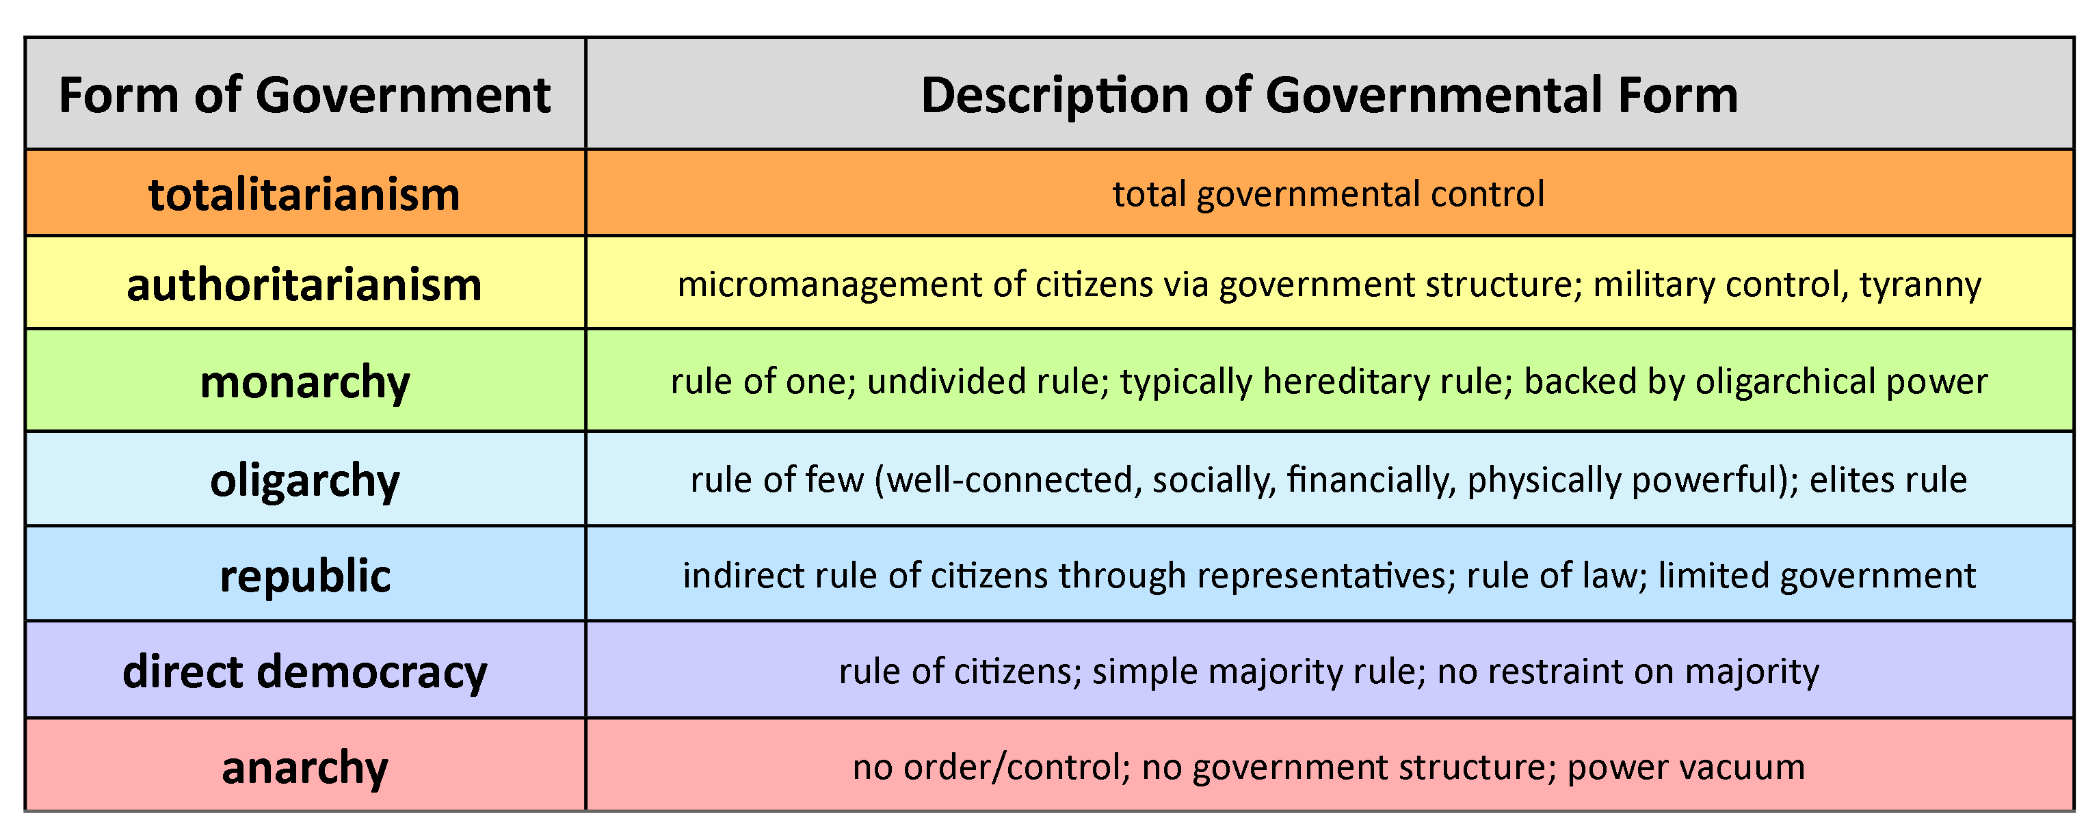

FORMS OF GOVERNMENT
The chart below should help you decide on a form of government for your Utopia. You may combine characteristics of more than one government and create a new name. You MUST be able to explain the form of govermnent that will be in place in your soceity and you must have reasons supporting why you chose it.

