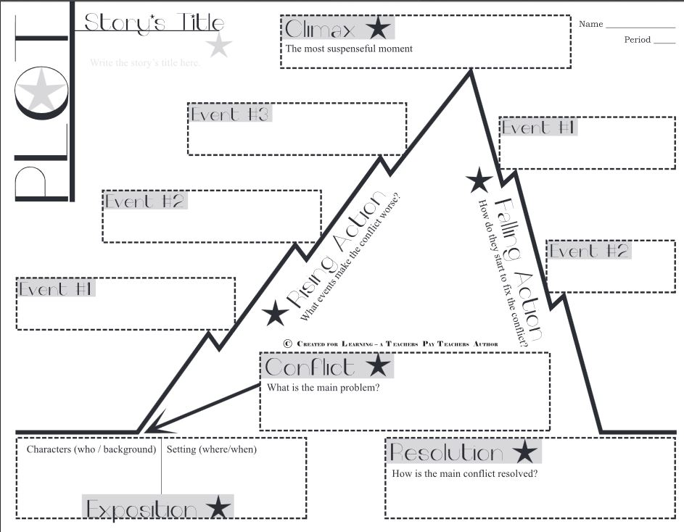

Response to “Fairy in a Jar” by David Lubar
What is the theme of the story, and how do the characters’ actions help demonstrate this theme? Support your answer with at least two specific details about characters’ actions or events from the text.
The theme of “Fairy in a Jar” is ______________________________________________
______________________________________________________________________
An example from the story that demonstrates the theme is _________________________
______________________________________________________________________
______________________________________________________________________
Another example is _______________________________________________________
______________________________________________________________________
______________________________________________________________________
In conclusion, ___________________________________________________________
______________________________________________________________________
______________________________________________________________________

Claim

Evidence/ Explanation 1

Evidence/ Explanation 2

Conclusion

